Green Training, Green Project and Green Construction as Antecedents of Customer Satisfaction: Examining the Mediating Role of Green Supply Chain Management
Benjabhon Mee-ngoen^{#1}, Suwat Nualkaw^{#2}, Tussanee Sirariyakul^{#3}, Narong Tomcharoen^{#4},
Kittisak Jermsittiparsert^{*5}

^{#1} College of Logistics and Supply Chain, Suan Sunandha Rajabhat University, Thailand
E-mail: Benjabhon.me@ssru.ac.th
^{#2} College of Logistics and Supply Chain, Suan Sunandha Rajabhat University, Thailand
E-mail: suwat.nu@ssru.ac.th
^{#3} Faculty of Business Administration, Ramkhamhaeng University, Thailand
E-mail: ttoy2009@hotmail.com
^{#4} Faculty of Business Administration, Ramkhamhaeng University, Thailand
E-mail: narong.tomcharoen@gmail.com
^{*5} Social Research Institute, Chulalongkorn University, Thailand
Corresponding author: E-mail: kittisak.j@chula.ac.th

Abstract- The prime objective of the present study is to examine the impact of green project, green construction and green training of the employees on the customer satisfaction. Moreover, the mediating role of green supply chain management is examined among the mentioned variables as well. In order to collect the data, 476 self-administered questionnaires were distributed among the customers of construction industry of Indonesia. The response rate was 84%. Moreover, in this research, the adoption of PLS path modelling for hypotheses testing was done because of multiple reasons. The findings of the study accepted all proposed hypothesis. It shows that construction firms should focus on their environmentally friendly activities to make the customer satisfied. The findings of the study are important for the practitioners and policy makers of the construction industry by which they can make the customer satisfied through meeting the expectations of the customers. Furthermore, present study fills the gap of limited studies addressing environmental issues in supply chain.

Keywords; Green Training, Green construction, Green Project, GSCM, Indonesia

1. Background
The Economic development of Indonesia is influenced by the construction industry a lot. In the process of development, it is the major contributor because it provides the physical and basic foundation in the efforts of the development. Moreover, the living standards of the people are improved as well. The infrastructure is built and provided by the construction industry of any country. The infrastructure is provided for trade, manufacturing, energy, agriculture and others. This sector has the ability to generate economic growth in all of the sectors. If the green supply chain policy is adopted by the management of the organizations, the efforts and outputs of the organizations can be improved [1].
______________________________________________________________
International Journal of Supply Chain Management
IJSCM, ISSN: 2050-7399 (Online), 2051-3771 (Print)
Copyright © ExcelingTech Pub, UK (http://excelingtech.co.uk/)

This is the era of globalization in which the competition in construction sector has increased a lot. The older manufacturing strategies are totally altered by the industrialization of the economies. The modern concepts of green manufacturing, agile and lean are emerged as a result of globalization. Because of these mentioned strategies organizations are able to face the competition which is increasing day by day. Now organizations can meet the demands of the customers and can provide the products according to the flexible demand, fulfil the expectations of the customers, provide the best alternatives and implement the different manufacturing practices as well which are not been fully adopted by the Indonesian construction sector [2].
Green Concept is the base of today’s business world. Maximizing the efficiency of the resources is the main objective of the organizations. This maximization is to be done by minimizing the impact on environment, productivity and health of the human. In the manufacturing firms, SCM is the basic activity. For this reason, most of the firms are adopting the policy of GSCM in their operational practices by minimizing the wastage, pollution, reusing and recycling, less use of natural resources and less exertion of emission [3]. The expectations of the customers are given attention by a number of manufacturers. It is because the customers of the organizations are very knowledgeable and take the impact on the environment very seriously. In order to increase the productivity and efficiency of the organization, SCM interacts with customers, manufacturers and suppliers. For the sustainability of the business of organization, customer is the important stake holder. For this reason, it is really important to study GSCM and its impact on the satisfaction of the customers [4].
As mentioned earlier, in any organization, customers are important stakeholders. Organizations must give priority to the customers. Satisfaction of the customers has remained the focus of interest for the researchers and organizations. In recent past, organizations provide value added services to the customers in order to retain them. In order to satisfy the customers, service quality is also an important factor. Its been mentioned by a number of scholars that quality of services is very important to keep the customers loyal [5]. The main purpose of customers satisfaction is to meet the perception and expectations of the customers. Whereas, it is very important to mention that amount of expectation of the customer will be mainly dependent upon the behaviour of customer. In order to make customers satisfied, meeting the pre-purchase expectations of the customers is the main aspect and should be the main goal of the organizations [6].
Scholars mentioned that organizations must give priority to GSCM because it is friendly to the environment and economical as well in case of organizations adopt green strategies. In the operational management and its sustainability context, the concept of SCM is extended by the concept of GSCM by improving the performance of environment of services and products throughout the life cycle. A number of different barriers are faced by GSCM in the context of getting more sustainability including fewer financial resources availability [7]. Trust among the stake holders of the organization and lack of commitment by the top management can be the barrier towards the GSCM as well [8].
It is very important for the organizations to develop alignment among GSCM and HRM of the organization. This alignment was termed as green human resource management also known as GHRM, which may play important role to minimize the barriers of GSCM and to obtain the satisfaction of the customers. It is because GHRM is basically described as the alignment among traditional HRM which include appraisal of performance and training etc has a lot of contribution towards the environmental sustainability. It is because the behaviour of customers towards environment is getting proactive day by day [9].
Scholars have mentioned that the variables of GHRM including green learning, green training, and green recruitment has a significant impact on the performance of organization and also have impact of the satisfaction of customers as well [10]. The Important function of GHRM is to have training regarding environment so the knowledge and skills regarding environment can be developed. The behaviour and attitude of the customers will be changed as a result of environmental education (North, 1997). In order to improve the green product performance transformational leadership is also an important pre-requisite. Through Promoting green training efforts at the workplace of the organization, all these developments can be achieved [11].
In developing countries, GHRM is the potential area of study. In the context of Indonesia, the studies regarding green practices are very limited. Moreover, data collection regarding green HRM in Indonesia is very limited as well Therefore, it is very important to conduct the study regarding GHRM in Indonesia. This study can be an important learning tool so the social responsibility tool can be developed towards the environment. For the green learning of the stakeholders of organizations, green construction is also very important. It is because the idea of green construction has become famous and gained popularity as well in the housing industry of Indonesia [12].
In the green environmental issues, buildings play a major role [13]. Moreover, all around the world, sustainable buildings are being built to solve the issues of environment, from the stage of before construction to the stage of removing the construction material after disposing the building is very important and can have very toxic impact on the environment. On the same grounds, green development is linked with green building. Moreover, a number of construction activities, utilizing material of the green construction, and structure of the building is also concern of green building [14]. For this reason, green building is related to sustainability of the environment. It’s important also lies in the performance of organization [13].
Furthermore, sustainable construction is referred as control, develop, build and design a project which may leave negative impact on the public and environment [15]. Additionally, the concern of green building is employing and establishing healthier resources which also involves development of prototypes, demolition, maintenance, operation, renovation and construction. Therefore, to promote the activities of green building sustainable construction is the key throughout the world. Building the structure of building itself is also concerned to it. On the broader terms, green building has the intention to minimize the impact of green construction on green environment and its sustainability [16].
There are a number of benefits of renewable energy to the environment. The basic purpose of developing renewable energy is to develop the infrastructure which do not have the worst impact on the environment. In past, environment was second concern when cities and roads were built. Now practitioners are making regular efforts to have minimum impact of energy on the environment. Among the green projects, renewable energy is not the only project. The projects are increasing to restore the environment to its normal past state. Research is being done and billions of dollars are being spent by the organizations to clean the environment. All of these efforts are showing that green environment is largely being promoted. The goals related to green environment are getting more common. A number of different projects are being conducted to develop new technology which can prevent environment from the pollution. These projects also deal with the mitigating strategy to minimize the waste and maximize the energy as well [17].
The main purpose of this paper is to explore the importance of green environment and in this perspective, customer satisfaction is studied as a dependent variable in construction sector of Indonesia. Also, green supply chain management is considered as a significant mediator between Green Training, Green construction, Green Project and customer satisfaction.

2. Literature Review
2.1. Customer Satisfaction
To maximize the profit of the organization, the main objective is to satisfy the customers. The customer satisfaction will be high if the high level of services is provided to the customers. The customers satisfaction shows elements of the operations in terms with responsiveness, speed, quality of the products, and efficient structure of the cost [18, 39-41]. Researchers mentioned that Interest of individual customer regarding the environment is related to satisfaction for the environmentally friendly products. Organizations are facing challenges in terms of eco-consumer and environmental regulations in order to get more and information regarding the products being offered by the organizations. The customers who are satisfied with the products of the organization always recommend these products to others. Such customers provide positive WOM and work as the partner of the organization. Moreover, they remain loyal to the organizations as well [19].

2.2. Green Supply chain Management
A number of past studies have worked on the term ecological sustainability as a theme to study the management in the context of strategy and operations. In terms of these efforts, researchers have examined the concept of GSCM with different concepts like purchasing, manufacturing practices, process design, product design and mixture of these elements [20].
The base definition of GSCM is in the concept of SCM. In the main definition of SCM, component of green is added which involves addressing the relationship and influence of SCM towards the nature. The concept of GSCM is motivated by the mindset which is environmentally friendly. The mindset of the GSCM is in the competitiveness of the organization. The base of GSCM is to minimize or eliminate the wastes like solid wastes, chemicals, emissions and energy. A number of different environmentally friendly practices are adopted in terms of green design (engineering and marketing), practices of green procurement like environmentally friendly products, and certifying suppliers. The terms related quality environment management include perennation from pollution and internal measurement of the performance, transportation and packaging are also needed to be environmentally friendly, to a number of different products which are defined as recycling, remanufacturing, reuse and reduction [21].

2.3. Green Training
Among the practices of GHRM which may contribute towards the GSCM, researchers have highlighted environmental or green training also known as GT. Scholars have defined GT as the process in which training is provided on the job and regular education with intention to achieve targets of corporate management and purposes. As mentioned by researchers, GT is environmentally friendly training which enables staff to enhance the performance of the firms and issues related to environment [22].
Scholars revealed that there exists positive relationship among green training and green policies of the organization throughout the world. For instance, researchers claimed that in order to adopt green environmental practices, GT of the employees played very important role. Few other researchers also mentioned that there exists positive relationship among evolution management which is environmentally friendly and green training. Additionally, GT is very important for the green economy [23].

2.4. Green Construction
The basic purpose of green construction is to maximize the use of resources and minimize the activities related to construction which may have negative impact on the environment in order to achieve the natural resources like material, water, land and energy. Moreover, the protection of environment is guaranteed. Consumption of resources like emission reduction, reduction of waste and reduction in consumption of resources main other main objectives of green construction. There exists a number of different barriers of green construction which do not allow organizations to adopt the policies of green constructions. These obstacles include lack of green suppliers, knowledge, lack of awareness and financial constraints. Still a number of different approaches are adopted to minimize negativity associated with green construction. These policies may include using new and efficient machines, using sophisticated recycling techniques, and using automation for pre-fabrications. Onsite waste can be reduced by using these measures [24].

2.5. Green Projects
For the green projects, the green projects must also make sense in terms of finances to be viable. As mentioned before that the demand for the green projects is mounting with the passage of time having perception and image of high risks, showing that the manager of the project will be responsible to manage the budget with profit margins which are tighter on the projects related to green environment [25]. On the bases of these trends, this paper discusses the effective delivery of the project with minimum cost.

2.6. Hypothesis Development
2.6.1. Green Supply Chain and Customer Satisfaction
It’s been revealed by a number of researchers’ practices of GSCM like investment recovery, eco-design, cooperation with customers and green purchasing have significant positive link with satisfaction of the customers. As a result, GSCM has significant impact on the GSCM.
Researchers conducted another research to find out customers who are willing to pay more and are satisfied as well after using green products in the market which is consumer oriented where the behaviour of consumers regarding green products is important concern in the business [26].
H1: GSCM and Customer Satisfaction are significantly related to each other.

2.7. Green Training and Green supply chain management
A number of studies in past are conducted regarding impact of different practices done by firms to improve the performance of the organizations by adopting green policies. Green policies include the green training of the employees. The green training of the employees should play important role in producing clean environment. As a result, organization will be able to achieve its internal goals related to environment. As a result, the environment around the organizations also improves which shows the external environment. Researchers also found that green activities of the organization in terms of green training plays important role to achieve its needs towards GSCM. On the other hand, organizations are unable to achieve its goals related to GSCM in the absence of green training which results in facing a number of challenges. All of these researches show that green training is important for GSCM [27]. H: Green Training and GSCM are significantly related to each other.
H2: GSCM mediates the relationship between Green Training and Customer Satisfaction.

2.8. Green construction and Green supply chain management
There exists unusual characteristics of supply chain of construction like uncertainty of the high level, project vision and high fragmentation. In the construction sector, assemble and production is required for the projects related to construction. According to the research of the construction industry sustainable buildings can be developed with the help of saving cost by using less water and energy. Other actions of the green supply chain can be viewed as the important actions for the certification as well [28].
H3: Green construction and GSCM are significantly related to each other.
H4: GSCM mediates the relationship between Green construction and Customer Satisfaction.

2.9. Green Project and Green supply chain management
The basic purpose of GSCM is to incorporate the environmental concern in the SCM context, has come on the screen as the complete approach of the environment. Extensive, effective and efficient implementation of green practices is the main emphasize of GSCM which can be used to reduce the environmental impact. In turn which depends upon the ability of GSCM to manage different antecedents [30].
Researchers conducted study regarding team building and keeping that team together throughout different phases. These phases of projects include selection of team, design of the concept, activities of pre-design and designing the selection of the team [29].
H5: Green Project and GSCM are significantly related to each other.
H6: GSCM mediates the relationship between Green Project and Customer Satisfaction.

Following framework is developed from the review of past literature:
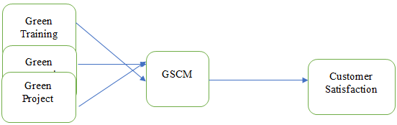

3. Methodology
The partial least square (PLS) path modelling is integrated in this study as a methodological technique for examining and testing the proposed hypotheses and effects of the constructs [31]. This method was proposed by [32] as a technique for path model estimation, involving those latent constructs which require multiple indicators to measure these latent constructs. [32] suggest that PLS is desirable in case when model involves large number of exogenous latent constructs for measuring only a few endogenous latent constructs. Thus, it is one of the structural equations modelling methods which measure the relationships between the constructs and between the latent constructs and their indicators through regression. In addition, unlike other covariance-based techniques, the partial least square method imposes no certain restriction concerning the use of interaction technique for testing the relationships.
In this research, the adoption of PLS path modelling for hypotheses testing was done because of multiple reasons. PLS is a statistical technique which has been widely adopted by various management and marketing researchers in their studies [33]. Around 476 self-administered questionnaires were delivered to the employees of construction companies of Indonesia and received 400 questionnaires with an 84 percent response rate.

4. Results
The above arguments depict the significance of structural and measurement models in Partial Least Square Structural Equation modelling. There are several advantages of PLS-SEM, for instance, it works well with small sample size and requires less cost as well as it does not make assumptions concerning the data and is also capable of analysing data that is measured through formative or reflective items [34].
In addition, the PLS-SEM is capable of effectively handling constructs with only single items, without even showing any identification problems and also efficiently estimate parameters, resulting in high-statistical power outcomes as compared to CB-SEM that has made the PLS-SEM application even more favourable under different research situations [34]. Therefore, a sequential two-stage approach was employed in this research for analysing the statistical results.

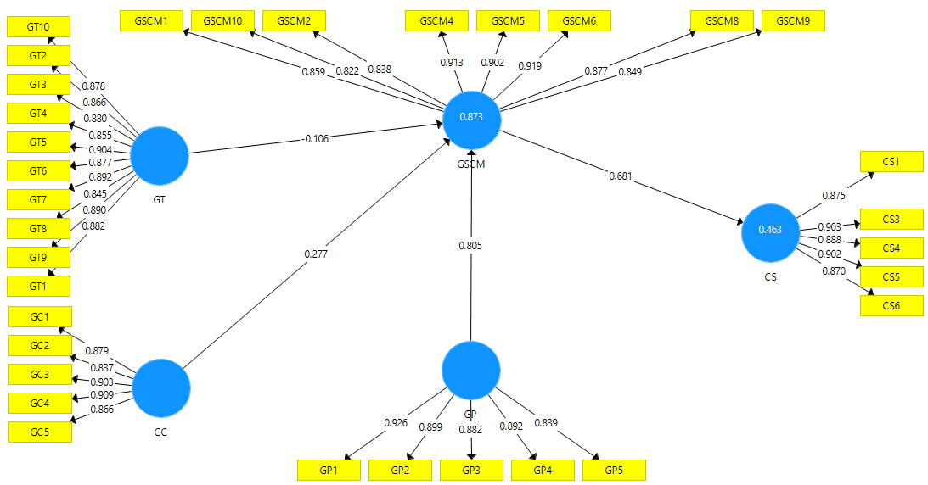
Figure 1. Measurement Model

In the PLS-SEM analysis, the outer model is estimated initially by checking the composite reliability, discriminant validity, and convergent validity [34]. This section involves the validity and the reliability assessment.

Table 1. Outer Loadings
 | CS | GC | GP | GSCM | GT
CS1 | 0.875
CS3 | 0.903
CS4 | 0.888
CS5 | 0.902
CS6 | 0.870
GC1 |  | 0.879
GC2 |  | 0.837
GC3 |  | 0.903
GC4 |  | 0.909
GC5 |  | 0.866
GP1 |  |  | 0.926
GP2 |  |  | 0.899
GP3 |  |  | 0.882
GP4 |  |  | 0.892
GP5 |  |  | 0.839
GSCM1 |  |  |  | 0.859
GSCM10 |  |  |  | 0.822
GSCM2 |  |  |  | 0.838
GSCM4 |  |  |  | 0.913
GSCM5 |  |  |  | 0.902
GSCM6 |  |  |  | 0.919
GSCM8 |  |  |  | 0.877
GSCM9 |  |  |  | 0.849
GT10 |  |  |  |  | 0.878
GT2 |  |  |  |  | 0.866
GT3 |  |  |  |  | 0.880
GT4 |  |  |  |  | 0.855
GT5 |  |  |  |  | 0.904
GT6 |  |  |  |  | 0.877
GT7 |  |  |  |  | 0.892
GT8 |  |  |  |  | 0.845
GT9 |  |  |  |  | 0.890
﻿GT1 |  |  |  |  | 0.882

In social sciences, the Cronbach alpha is traditionally used for measuring the reliability and internal consistency, while, a conservative measure is used in case of PLS-SEM [34]. [35] suggested composite reliability as a significant measure for the internal consistency. Therefore, composite reliability values were computed for assessing the internal consistency reliability, following [34] suggestion that composite reliability values must exhibit above 0.70 value. Further, the indicator reliability was also observed through outer factor loadings, which must exhibit above 0.50 values [32]. Once the validity and reliability of the constructs are established, structural model was estimated.

Table 2. Reliability
 | Cronbach's Alpha | rho_A | CR | (AVE)
CS | 0.933 | 0.935 | 0.949 | 0.788
GC | 0.926 | 0.928 | 0.944 | 0.773
GP | 0.933 | 0.934 | 0.949 | 0.789
GSCM | 0.955 | 0.957 | 0.962 | 0.762

Convergent validity is defined by [34] as the degree that positive correlation exists between measures of the same construct, for instance, in such a way that indicators of a construct share or converge high percentage of variance. The indicators’ outer loadings and AVE were also considered to ascertain the model’s convergent validity. AVE or Average variance extracted shows the mean of indicators’ squared loadings, which must be equal or above 0.50 to be acceptable [35]. Having acceptable AVEs indicate that more than half of indicators’ variance is explained by the construct.

Table 3. Validity
 | CS | GC | GP | GSCM | GT
CS | 0.888
GC | 0.653 | 0.879
GP | 0.650 | 0.696 | 0.888
GSCM | 0.681 | 0.738 | 0.724 | 0.873
GT | 0.629 | 0.735 | 0.690 | 0.708 | 0.877

Discriminant validity is referred as the extent that a particular model construct is practically different from other model constructs. [34] suggest that adequate discriminant validity is achieved when a particular construct is completely unique from the rest of the model constructs. In PLS-SEM, discriminant validity is measured by performing two measures. However, [36] criterion is a relatively more conservative measure for discriminant validity. Therefore, AVE square root values were compared to the correlations of latent variables. For each construct, the AVE square roots are required to be higher in comparison to latent variables’ highest correlation with other constructs. According to [34] it shows a construct’s shared variance with its indicators as compared to any other model construct.

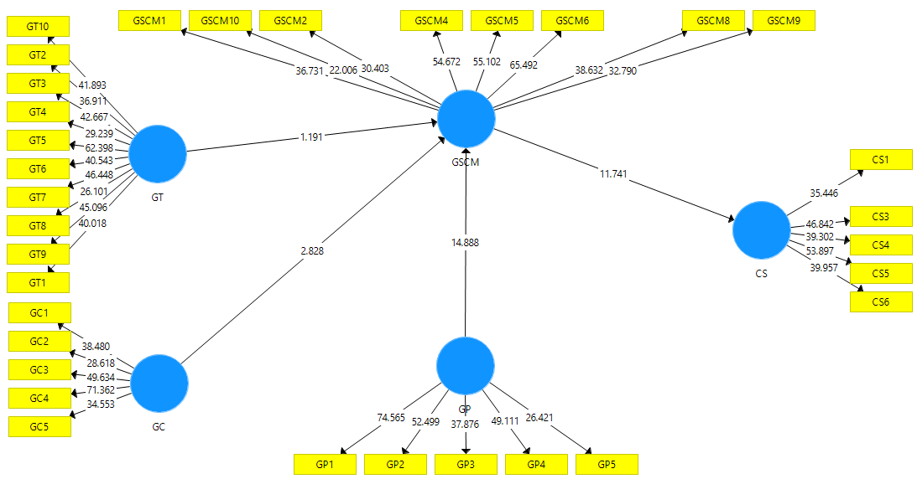
Figure 2. Structural Model

Evaluation of the inner model helps in explaining the model’s predictive ability. Thus, in PLS-SEM, the significance of path coefficients and coefficient of determination (R²) are the important evaluation criteria in this regard [34]. In case of inner model assessment, the major considerations include coefficient of determination, path coefficients, effect sizes f², and the predictive relevance [34]; [32].

Table 4. Direct Relationship
 | (O) | (M) | (STDEV) | (|O/STDEV|) | P Values
GC -> CS | 0.189 | 0.195 | 0.071 | 2.648 | 0.004
GC -> GSCM | 0.277 | 0.284 | 0.098 | 2.828 | 0.002
GP -> CS | 0.548 | 0.544 | 0.053 | 10.251 | 0.000
GP -> GSCM | 0.805 | 0.796 | 0.054 | 14.888 | 0.000
GSCM -> CS | 0.681 | 0.684 | 0.058 | 11.741 | 0.000
GT -> CS | -0.072 | -0.071 | 0.062 | 1.173 | 0.120
GT -> GSCM | -0.106 | -0.103 | 0.089 | 1.191 | 0.117

The bootstrapping procedure was then performed to analyse the path coefficients’ significance using Smart PLS 2.0. For bootstrapping procedure, 362 cases were included by setting 5000 subsamples without making any changes in the sign [34]. The estimation of parameters was done on the basis of path-weighting scheme [37]. In addition, the bootstrapping procedure presents standard errors, which helps in testing the proposed hypotheses and path coefficients significance [34].

Table 5. Mediation
 | (O) | (M) | (STDEV) | (|O/STDEV|) | P Values
GC -> GSCM -> CS | 0.189 | 0.195 | 0.071 | 2.648 | 0.004
GP -> GSCM -> CS | 0.548 | 0.544 | 0.053 | 10.251 | 0.000
GT -> GSCM -> CS | -0.072 | -0.071 | 0.062 | 1.173 | 0.120

The next step is to examine the R-square value of endogenous latent variables also known as coefficient of determination [32]. [38] have proposed acceptable threshold range for the R² value, for instance, Chin indicated 0.33, 0.19, and 0.67 as the moderate, good, and weak values, respectively.

Table 6. R-square
 | R Square
CS | 0.463
GSCM | 0.873

5. Conclusion
This is the era of competition in which organizations are facing immense pressure. In order to survive in this present stiff competition organizations must retain their customers by making them satisfied. The customers are satisfied when their expected needs are fulfilled. The present study examined the impact of green project, green training and green construction on customer satisfaction with mediating role of GSCM. For analysis 476 questionnaires were distributed among target audience and the response rate was 82%. For analysis, the researchers have used PLS-SEM. All of the proposed hypothesis of the study has stand true showing that the people are getting aware of environmental issues. They are very touchy for their environment. The organizations must give their employees training regarding the environment and employee the projects which are environment friendly as well. Moreover, the material used during the construction should be environmentally friendly as well. By this way organizations can satisfy their customers and retain them for longer period of time. The findings of the study are important for the policy makers and practitioners of supply chain and construction industry of Indonesia because by using this study they can derive policies and strategies to make customers satisfy.

REFERENCES

- A. Budiwibowo, B. Trigunarsyah, I. S. Abidin, and H. G. Soeparto, “Competitiveness of the Indonesian construction industry,” Journal of Construction in Developing Countries, Vol. 14, No. 1, pp. 51-68, 2009.
- D. Raben, B. Helfrich, D. C. Chan, F. Ciardiello, L. Zhao, W. Franklin, and P. A. Bunn, “The effects of cetuximab alone and in combination with radiation and/or chemotherapy in lung cancer,” Clinical Cancer Research, Vol. 11, No. 2, pp. 795-805, 2005.
- K. G. A. S. Waidyasekara and R. L. N. Sandamali, “Impact of green concept on business objectives of an organisation,” 2012.
- T. A. Chin, H. H. Tat, Z. Sulaiman, M. Zainon, and S. N. Liana, “Green supply chain management practices and sustainability performance,” Advanced Science Letters, Vol. 21, No. 5, pp. 1359-1362, 2015.
- J. M. Agbor, “The relationship between customer satisfaction and service quality: A study of three Service sectors in Umeå,” 2011.
- S. P. Anantadjaya, A. Walidin, E. Sari, and I. M. Nawangwulan, “Consumer Behavior, Supply chain management and Customer satisfaction: An investigative study in small and medium enterprises,” In Supply Chain Management and Customer Satisfaction: An Investigative Study in Small and Medium Enterprises (August 30, 2007). Proceeding, International Seminar on Industrial Engineering and Management, 2007.
- J. Rauer, and L. Kaufmann, “Mitigating external barriers to implementing green supply chain management: A grounded theory investigation of green‐tech companies' rare earth metals supply chains,” Journal of Supply Chain Management, Vol. 51, No. 2, pp. 65-88, 2015.
- S. Luthra, D. Garg, and A. Haleem, “An analysis of interactions among critical success factors to implement green supply chain management towards sustainability: An Indian perspective,” Resources Policy, Vol. 46, 37-50, 2015.
- L. M. Graves, J. Sarkis, and Q. Zhu, “How transformational leadership and employee motivation combine to predict employee pro environmental behaviours in China,” Journal of Environmental Psychology, Vol. 35, 81-91, 2013.
- N. Auranzeb and A. Bhutto, “Influence of talent management in enhancing organization performance: Evidence from service sector companies in Pakistan,” Industrial Engineering Letters, Vol. 6, No. 6, pp. 50, 55, 2016.
- Y. S. Chen and C. H. Chang, “The determinants of green product development performance: Green dynamic capabilities, green transformational leadership, and green creativity,” Journal of Business Ethics, Vol. 116, No. 1, pp. 107-119, 2013.
- N. Z. Abidin, N. A. Yusof, and A. A. Othman, “Enablers and challenges of a sustainable housing industry in Malaysia,” Construction Innovation, 2013.
- B. G. Hwang and J. S. Tan, “Sustainable project management for green construction: challenges, impact and solutions,” In World Construction Conference (pp. 171-9) , 2012.
- A. B. Kamarudin, M. Fazli, M. Sam, T. Md Nor Hayati, R. Ismi, and M. Norhana, “Green technology compliance in Malaysia for sustainable business development,” Journal of Global Management, Vol. 2, No. 1, pp. 55-65, 2011.
- N. Z. Abidin, N. A. Yusof, and A. A. Othman, “Enablers and challenges of a sustainable housing industry in Malaysia,” Construction Innovation, 2013.
- H. M. Abualrejal, Z. Mohamed Udin, and S. Mohtar, “Green building toward construction sustainability: energy efficiency with material and design aspects,” Journal of Technology and Operations Management, Vol. 100, No. 109, pp. 100-109, 2017.
- J. C. Nagle, “Green harms of green projects,” Notre Dame JL Ethics and Pub. Pol'y, Vol. 27, 59, 2013.
- S. W. Kim, “Effects of supply chain management practices, integration and competition capability on performance,” Supply Chain Management: An International Journal, 2006.
- T. J. Brown, T. E. Barry, P. A. Dacin and R. F. Gunst, “Spreading the word: Investigating antecedents of consumers’ positive word-of-mouth intentions and behaviors in a retailing context,” Journal of the Academy of Marketing Science, Vol. 33, No. 2, pp. 123-138, 2005.
- A. A. King and M. J. Lenox, “Does it really pay to be green? An empirical study of firm environmental and financial performance: An empirical study of firm environmental and financial performance,” Journal of Industrial Ecology, Vol. 5, No. 1, pp. 105-116, 2001.
- A. A. Hervani, M. M. Helms, and J. Sarkis, “Performance measurement for green supply chain management,” Benchmarking: An International Journal, 2005.
- B. F. Daily and S. C. Huang, “Achieving sustainability through attention to human resource factors in environmental management,” International Journal of Operations and Production Management, 2001.
- A. A. Teixeira, C. J. C. Jabbour, A. B. L. de Sousa Jabbour, H. Latan, and J. H. C. De Oliveira, “Green training and green supply chain management: evidence from Brazilian firms,” Journal of Cleaner Production, Vol. 116, 170-176, 2016.
- S. Balasubramanian and V. Shukla, “Green supply chain management: an empirical investigation on the construction sector,” Supply Chain Management: An International Journal, 2017.
- N.S. Neema, “Interrogating gender dynamics in the context of indigenous and innovative social work practice in Kenya,” International Journal of Innovation, Creativity and Change, Vol. 3, No. 4, pp. 30-60, 2018.
- H. D. Mallikarathna and C. C. Silva, “The Impact of Green Supply Chain Management Practices on Operational Performance and Customer satisfaction,” 2019.
- A. A. Teixeira, C. J. C. Jabbour, A. B. L. de Sousa Jabbour, H. Latan, and J. H. C. De Oliveira, “Green training and green supply chain management: evidence from Brazilian firms,” Journal of Cleaner Production, Vol. 116, pp. 170-176, 2016.
- E. R. D. S. Zampese, R. G. Moori, and A. Caldeira, “Green marketing as a mediator between supply chain management and organizational performance,” RAM. Revista de Administração Mackenzie, 17, No. 3, pp. 183-211, 2016.
- M. A. Wibowo, N. U. Handayani, and A. Mustikasari, “Factors for implementing green supply chain management in the construction industry,” Journal of Industrial Engineering and Management, Vol. 11, No. 4, pp. 651-679, 2018.
- D. P. van Donk, T. van der Vaart, A. Awaysheh, and R. D. Klassen, “The impact of supply chain structure on the use of supplier socially responsible practices,” International Journal of Operations and Production Management, 2010.
- J. Henseler, C. M. Ringle, and R. R. Sinkovics, The use of partial least squares path modeling in international marketing. In New challenges to international marketing. Emerald Group Publishing Limited, 2009.
- J. Henseler, C. M. Ringle, and M. Sarstedt, Using partial least squares path modeling in advertising research: basic concepts and recent issues, Handbook of Research on International Advertising, Vol. 252, 2012.
- W. Reinartz, M. Krafft, and W. D. Hoyer, “The customer relationship management process: Its measurement and impact on performance,” Journal of Marketing Research, Vol. 41, No. 3, pp. 293-305, 2004.
- W.M. Ndungi, “Transcultural issues in regional settlement of refugees,” International Journal of Innovation, Creativity and Change, Vol. 3, No. 4, pp. 90-105, 2018.
- R. P. Bagozzi and Y. Yi, “On the evaluation of structural equation models,” Journal of the academy of marketing science, Vol. 16, No. 1, pp. 74-94, 1988.
- C. Fornell and D. F. Larcker, “Structural equation models with unobservable variables and measurement error: Algebra and statistics,” 1981.
- V. E. Vinzi, L. Trinchera, and S. Amato, PLS path modeling: from foundations to recent developments and open issues for model assessment and improvement. In Handbook of partial least squares (pp. 47-82). Springer, Berlin, Heidelberg, 2010.
- W. W. Chin, Bootstrap cross-validation indices for PLS path model assessment. In Handbook of partial least squares (pp. 83-97). Springer, Berlin, Heidelberg, 2010.
- K. Jermsittiparsert, T. Sriyakul, and K. Kunathikornkit, “The Mediating Role of Customer Satisfaction in the Relationship Between Atmospherics on Customer Behaviour: Stimulus Organism Response Model Approach in the Spa Industry of Thailand,” Journal of Computational and Theoretical Nanoscience, Vol. 16, No. 11, pp. 4738-4747, 2019.
- K., Chienwattanasook, K. Jermsittiparsert, and K. Jarinto, “Customer Satisfaction, Word-of-Mouth and Conventional Banks in Thailand,” International Journal of Innovation, Creativity and Change, Vol. 10, No. 1, pp. 320-334, 2019.
- W. Joemsittiprasert, P. Siriattakul, and K. Jermsittiparsert, “The Effect of Trust, Commitment, and Salesperson Ethical Behavior on Customer Retention: The Mediating Role of Customer Satisfaction: Banking Industry of Thailand,” International Journal of Psychosocial Rehabilitation, Vol. 23, No. 4, pp. 808-821, 2019.

