**Factors Affecting the Decision to Purchase Life Insurance Products in Vietnam**

Nga Phan Thi Hang

University of Finance – Marketing (UFM), HCMC, Vietnam

Email: phannga@ufm.edu.vn

Corresponding author: phannga@ufm.edu.vn

My-Linh Thi Nguyen

University of Finance – Marketing (UFM), HCMC, Vietnam

Email: ntmylinh@ufm.edu.vn

***Abstract* - In the current momentum of economic development, insurance increasingly demonstrates its essential role in socio-economic life. The critical part of insurance is financial service and social security mechanisms in the national economy. The life insurance product is a necessary product with both mental and physical value. Therefore, understanding life insurance’s meaning and benefits help customers have a positive outlook on life. Thus, the paper objective determines the factors affecting the decision to purchase life insurance products in Vietnam. The results showed five determinants: Benefit awareness, subjective standards, attitude towards life insurance, financial literacy, and access to the product. All five factors affected the intent and the decision to purchase life insurance products in Vietnam with 1% significance. Since then, the authors gave several recommendations to enhance the decision to buy life insurance products.**

***Keywords:*** *Life, insurance, intent, decision, purchasing, and UFM.*

**1. Introduction**

In the world, research on life insurance in general and buying behavior of Life insurance and survey on demand for life insurance has a lot. Life insurance allows individuals and households to share with many others and supports financial losses from undesirable risks such as death from their base salary share [18], [7]. Life insurance is an essential financial tool for allocating resources against life uncertainties and is a critical element in long-term financial planning [1].

______________________________________________________________

***International Journal of Supply Chain Management***

IJSCM, ISSN: 2050-7399 (Online), 2051-3771 (Print)

Copyright © ExcelingTech Pub, UK (<http://excelingtech.co.uk/>)

In Vietnam, there are also many studies on this issue at different levels. Studies examined from both individual and market perspectives. Market research and customer satisfaction are fundamental because they promote the economy’s development in general, but achieving this needs to be based on a critical decision. Whether or not customers will purchase life insurance products.

Results studied life insurance as one type of insurance launched quite early with the original purpose of insurance for customers’ life and death events [5], [12]. Today, with the essential characteristics of savings and risk and based on traditional products, businesses’ life insurance products are increasingly diversified and diversified to meet participants’ different purposes for consumption, protection, and risk.

The audience, goals, and coverage of these products also increasingly expand towards effective financial plans for participants from birth to retirement. With great benefits and meeting many different purposes of life insurance, however, with consumers’ economic growth and income, the school’s purchase of life insurance products is underdeveloped at a commensurate level.

**2. Literature Review**

**2.1** **The Decision (Decision)**

Results showed that the basic theory of marketing, consumption is an essential human behavior. It is the act to satisfy aspirations, individual imagination, and the physical and emotional needs of an individual or organization through the purchase and use of those products [3], [21]. In other words, consumer behavior is consumer decisions related to the use of resources: finance, time, effort, exchange experience to satisfy the needs and desires of the fish multiply [4].

The decision to buy a life insurance product is the process of accessing, choosing, and using life insurance services [10], [11]. This behavior performed independently from the influence of internal factors such as risk attitude; product attitude; attitude to buying action) but influenced by external factors such as subjective norms or controlling perceived behavior or intentions [28].

**2.2 The Intent (Intent)**

Results studied customer behavior influenced by both intentions and behavioral control perception. The purpose is the direct premise of the actual conduct [6], [20]. Behavioral intent is a sign of a person’s willingness to perform a specified act or action. In the field of life insurance, the intention to buy life insurance is understood as the person’s future goal of purchasing insurance over a specified period [14].

Behavioral intent is a sign of a person’s willingness to perform a specified act or action. Behavioral intention is seen as the immediate premise of the show. Purchase intent is the probability that a customer purchased a product or service [2], [14]. To evaluate purchase intent, marketers use predictive modeling to determine the likelihood of future results based on historical data. Buying a plan is one of the oldest and widely used measures in marketing research. Its use spans various research types (testing new products and products, packaging testing, content testing, innovation and brand positioning, and loyalty) [17], [30].

**2.3 Benefit awareness (Aware)**

Results showed that perceiving benefits with a life insurance product is a collection of positive or negative reviews of an individual related to a life insurance product [8]. These assessments can be obtained through real experience or sometimes influenced by those around them sharing life insurance information [24].

A person’s attitude or perception towards an insurance product is expressed through a useful perception of a life insurance product. Perceptions of benefit or valid perceptions are the set of positive or negative reviews of an individual regarding a life insurance product [26]. When analyzing useful consciousness, it implies that many people aware of insurance’s usefulness have a better purchasing insurance attitude [3], [19]. Based on the concept mentioned above and studies, authors give hypothesis H1 following:

*Hypothesis H1: Benefits awareness (Aware) positively impacts the intent and decision to purchase life insurance products in Vietnam*

**2.4 Subjective standards (Stan)**

Rational action theory and intended behavioral approach, subjective criteria explained by knowledge of a person’s beliefs about certain vital people who think the subject should or should not act moving [7], [25]. The structure of subjective norms is the cognitive, social pressure of participating or not participating in behavior [23]. It is thought that the subjective criterion is determined by the total amount of normative belief that attained relative to the expectation of an important implication.

Normative allusion elicited through questions about which groups of people will or disapprove, support, or dislike an individual’s performance of specific behaviors [19], [27]. Subjective norms are described as the individual’s perception of social pressures related to performing or not performing a behavior [30].

In life insurance, subjective benchmarks reflect consumer perceptions of the reference group’s influence on the ability to buy life insurance. Previous studies have suggested a positive effect of personal standards on people’s intentions to purchase insurance [20], [25]. Based on the concept as mentioned earlier and studies, authors give hypothesis H2 following:

*Hypothesis H2: Subjective standards (Stan) positively impact the intent and the decision to purchase life insurance products in Vietnam.*

**2.5 Attitude towards life insurance (Attit)**

Results studied that attitudes classified into two different categories: attitudes toward objects and attitudes towards behaviors [13], [29]. In the research scope of the thesis, the philosophy to be researched is that buying life insurance. There are attitudes toward behavior or life insurance decisions directed towards what the individual believes.

People bought insurance brings about (positive or negative): purchase life insurance is useful or purchases life insurance is a waste of money [11], [18]. According to a research review, attitudes towards buying life insurance affect their buying intentions [31]. Based on the concept as mentioned above and studies, authors give hypothesis H3 following:

*Hypothesis H3: Attitude towards life insurance (Attit) positively impacts the intent and the decision to purchase life insurance products in Vietnam.*

**2.6 Financial literacy (Finan)**

Results showed that behavioral theory intended to develop with the addition of the cognitive factor that controls behavior as a trust control variable and demonstrates the ease or difficulty in acting [22]. It is a form of belief in having the necessary resources and the opportunity to perform a specific behavior. Financial literacy positively affects intention to buy life insurance [15], [26].

Financial literacy focuses on managing personal financial affairs effectively, including the knowledge to make the right decisions about personal finances such as investing, insurance, real estate, payment Tuition for college, budget, retirement, and tax planning [25].

Financial literacy is also related to mastering economic principles and concepts such as financial planning, compounding, debt management, useful saving techniques, and the time value of money. Financial knowledge positively influences buying life insurance [27]. Based on the concept mentioned above and studies, authors give hypothesis H4 following:

*Hypothesis H4: Financial literacy (Finan) positively impacts the intent and the decision to purchase life insurance products in Vietnam.*

**2.7 Access to the product (Access)**

Results studied that behavioral control perception divided into a group of internal factors related to knowing about insurance products and understanding the financial sector called knowledge [5], [29]. Finance, a group of external factors related to the degree of advantage or difficulty in implementing intentions and behavior (deciding) to buy insurance products, is known as product accessibility [12].

Product accessibility positively affects the motivating process from intent to buying behavior life insurance [9], [17]. Based on the concept mentioned above and studies, authors give hypothesis H5 following:

*Hypothesis H5: Access to the product (Access) positively impact the intent and the decision to purchase life insurance products in Vietnam.*

*Hypothesis H6: the intent is affecting the decision to purchase life insurance products in Vietnam.*

A research model for factors affecting the banking service quality of commercial banks in Vietnam following:

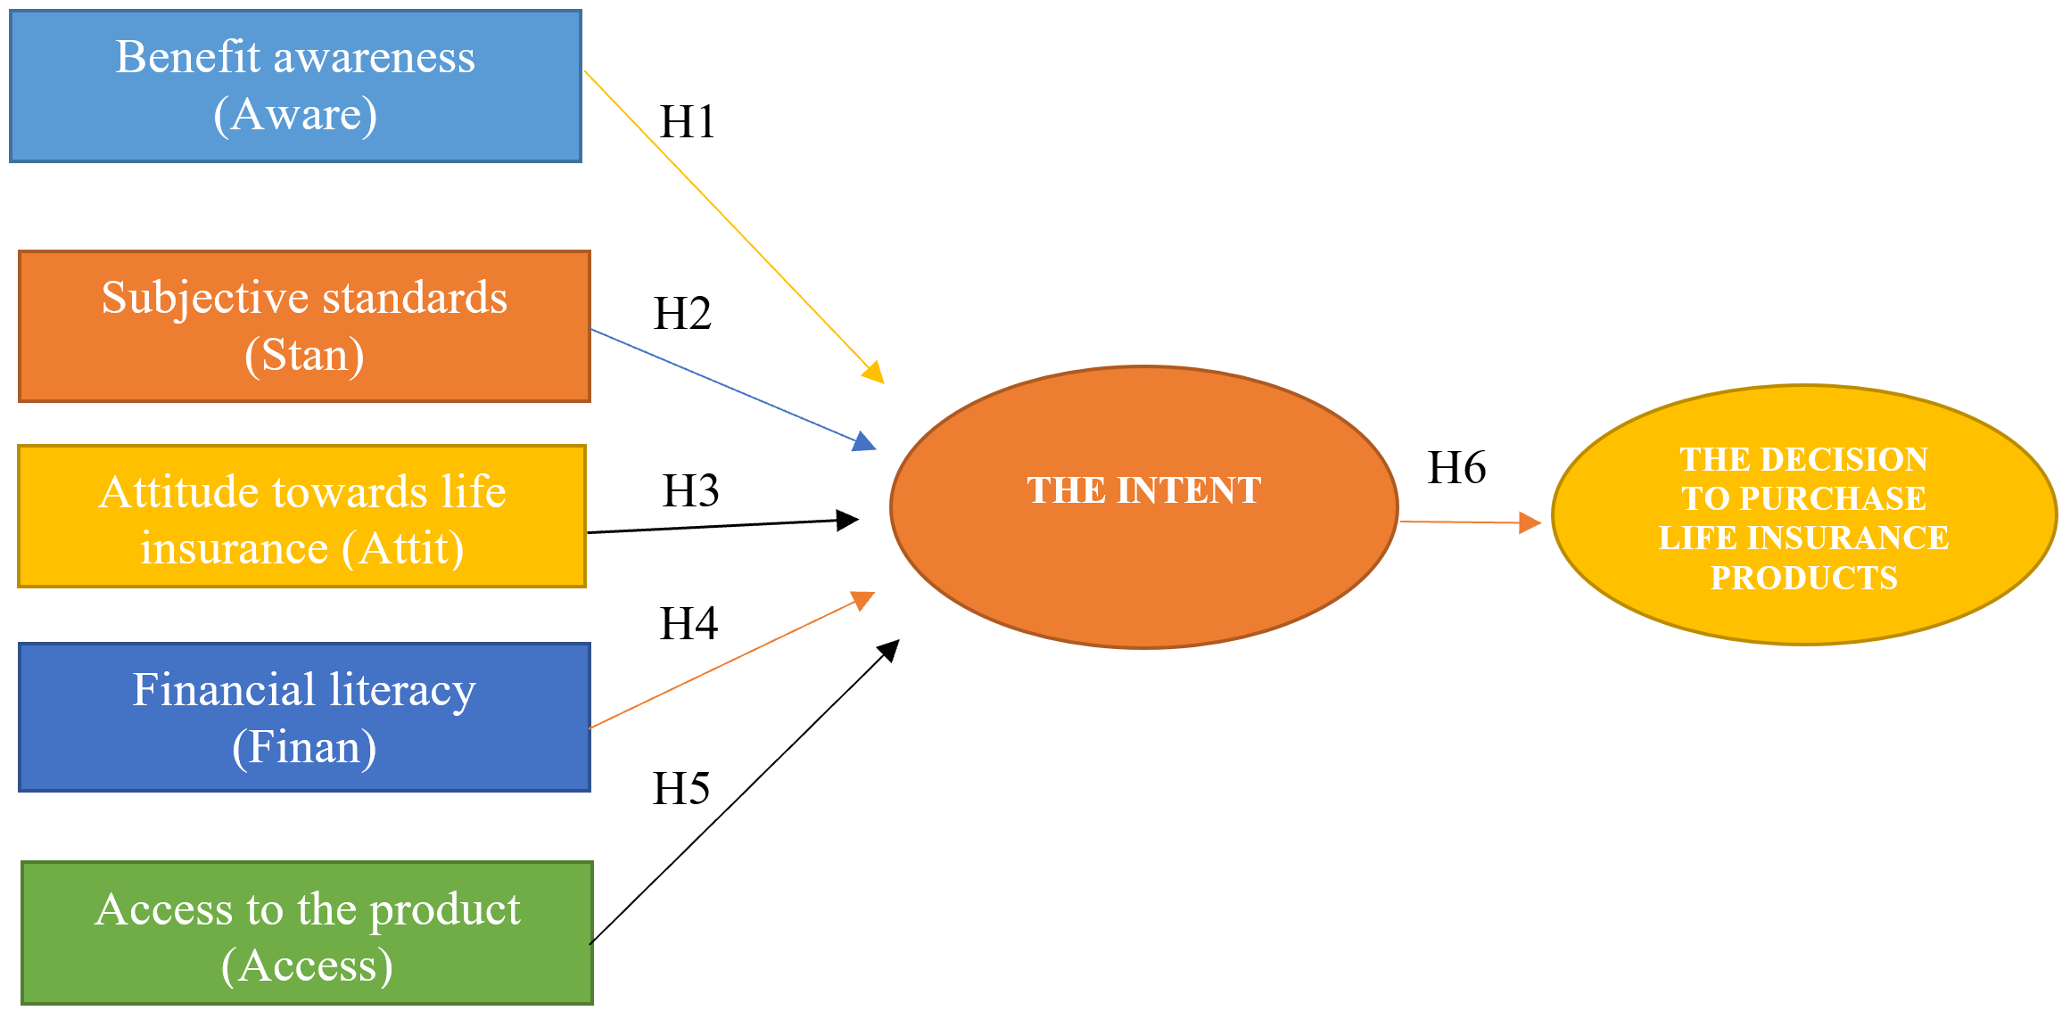

(Source: Researchers discovered)

**Figure 1.** A research model for factors affecting the intent and the decision to purchase life insurance products in Vietnam

**3. Methods of Research**

The research method of the topic is a combination of qualitative research methods and quantitative research methods:

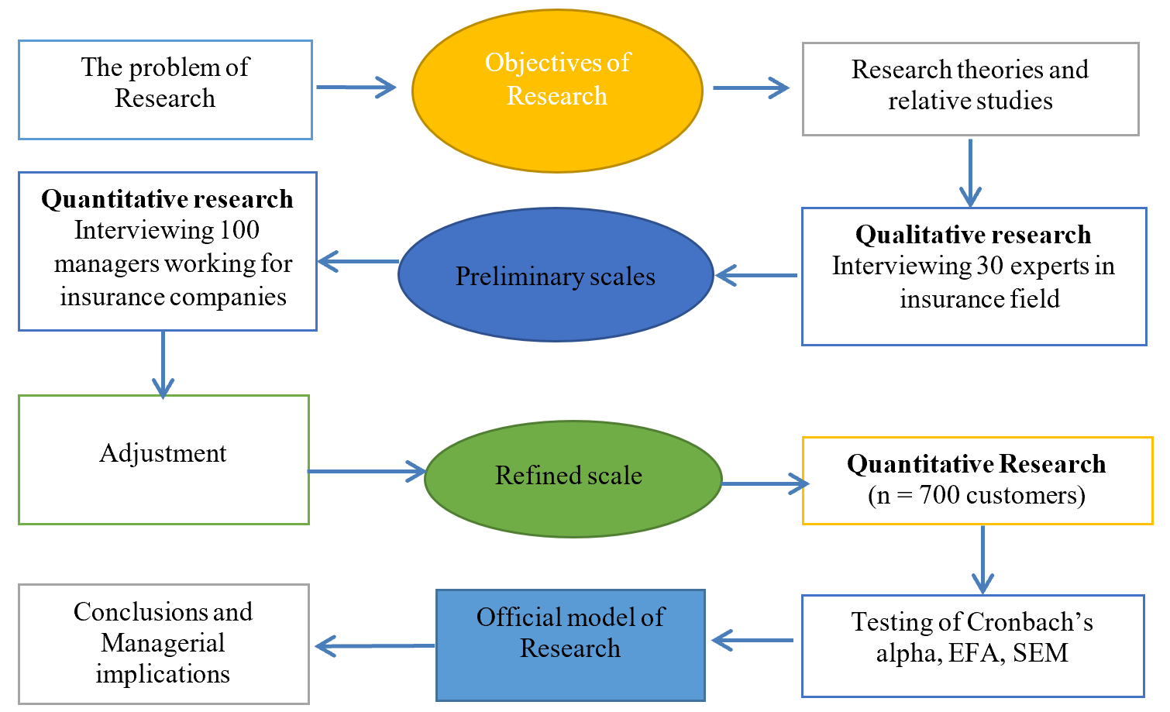

(Source: Researchers proposed)

**Figure 2.** A research model for factors affecting the intent and the decision to purchase life insurance products in Vietnam

The authors conducted qualitative research based on technical discussions with 30 persons who are insurance field experts. The authors tested the preliminary examination and group discussions with experts from large insurance enterprises. This work did gain an inadequate understanding of life insurance and the factors influencing the intent and the intent affecting the decision to purchase life insurance products in Vietnam and make further adjustments to the scale of research concepts [16].

The findings of the article revealed five factors: Benefit awareness (Aware), subjective standards (Stan), attitude towards life insurance (Attit), financial literacy (Finan), and access to the product (Access). The data cleaned using the screening data tool through 2 steps: checking for error to see if it is within the allowed range, then fixing the error in the file - finding and correcting the error in the data file [16].

Quantitative research: authors are to save money and time; the report used survey sampling to gather data from 100 managers working for insurance companies - the sample size calculated by the study’s estimation and processing procedure. Survey questionnaires were used to collect data. On that basis, the authors inherit and apply the amendment after the survey and in-depth interviews with experts; the scales adjusted to suit the Vietnamese context [16].

The quantitative study was conducted with an expected sample size of n = 700 customers related to buying life insurance. The authors used a convenient sampling method to pick a sample, but 685 samples were processed, leaving 15 samples unprocessed [16].

The authors used SPSS tools to measure Cronbach’s Alpha’s trust coefficient, EFA: explore factor analysis, confirmation factor analysis (CFA), and structural equation modeling (SEM) for the scales’ reliability. Finally, the writers gave suggestions [16].

**4. Research Results**

Testing Cronbach’s alpha for factors affecting the banking service quality of commercial banks in Vietnam following:

**Table 1.** Testing of Cronbach’s alpha for the Intent (Intent)

|  |  |  |  |  |  |
| --- | --- | --- | --- | --- | --- |
| **Items** | | | | | **Cronbach’s alpha** |
| **The Intent (Intent)** | | | | | **0.952** |
| Intent1 | He/she will buy life insurance in the future | | | | 0.943 |
| Intent2 | He/she plans to buy life insurance soon (next five years) | | | | 0.893 |
| Intent3 | He/she is not sure that he/she will buy life insurance in the future | | | | 0.952 |
| **The Decision (Decision)** | | | | | **0.902** |
| Decision1 | | | | He/she has purchased life insurance through an insurance advisor/broker/bank | 0.892 |
| Decision2 | | | | He/she persuaded to buy life insurance without the intention from the start | 0.839 |
| Decision3 | | | | He/she actively searches and buys life insurance | 0.895 |
| Decision4 | | | | He/she recommends life insurance to my family and friends | 0.863 |
| **Benefit awareness (Aware)** | | | | | **0.959** |
| Aware1 | | Life insurance is a form of savings for the future | | | 0.946 |
| Aware2 | | Life insurance provides financial support for life events (getting married, having children, retiring) | | | 0.949 |
| Aware3 | | Life insurance provides guarantees for dependents | | | 0.954 |
| Aware4 | | Life insurance contributes to a better life in the future | | | 0.935 |
| **Subjective standards (Stan)** | | | | | **0.861** |
| Stan1 | | All those influencing on he/she thinks he/she should buy life insurance | | | 0.809 |
| Stan2 | | Everyone in his/her environment thinks that he/she should buy life insurance | | | 0.819 |
| Stan3 | | His/her friends all own life insurance | | | 0.855 |
| Stan4 | | His/her relatives support me to buy life insurance | | | 0.810 |
| **Attitude towards life insurance (Attit)** | | | | | **0.966** |
| Attit1 | | He/she thinks buying life insurance is a necessary option | | | 0.949 |
| Attit2 | | He/she buys life insurance helps to set up future financial plans | | | 0.963 |
| Attit3 | | He/she buys life insurance helps to feel secure to work and enjoy life | | | 0.962 |
| Attit4 | | He/she buys life insurance as a way to accumulate life | | | 0.946 |
| **Financial literacy (Finan)** | | | | | **0.966** |
| Finan1 | | | He/she has enough knowledge to buy life insurance | | 0.949 |
| Finan2 | | | Life insurance products are effortless and straightforward | | 0.960 |
| Finan3 | | | He/she knows how life insurance works | | 0.963 |
| Finan4 | | | He/she is very confident in my abilities regarding future financial plans | | 0.948 |
| **Access to the product (Access)** | | | | | **0.904** |
| Access1 | | | He/she know where life insurance products sold | | 0.889 |
| Access2 | | | He/she know there are many distribution channels for life insurance products | | 0.844 |
| Access3 | | | When looking for information on insurance financial services, he/she know exactly where to get it and where to get it | | 0.900 |
| Access4 | | | He/she finds life insurance information on the company’s website and in newspapers | | 0.870 |

(Source: Researchers proposed by SPSS 20.0)

Table 1 showed that all of Cronbach’s alpha is more than 6.0. This article applied a quantitative research method with the help of a small qualitative study. First of all, the authors’ group conducted in-depth interviews with experts, including current and potential insurance companies’ clients, insurance finance agents, advisors, and business managers, to check the scales’ appropriateness determined from the theoretical basis synthesis.

Then the authors adjusted the model and scale (mainly words) to suit the specific context of the life insurance field. Then the group of authors conducted a survey study. The program’s content presents the process and results of in-depth interview research and detailed steps to analyze survey data.

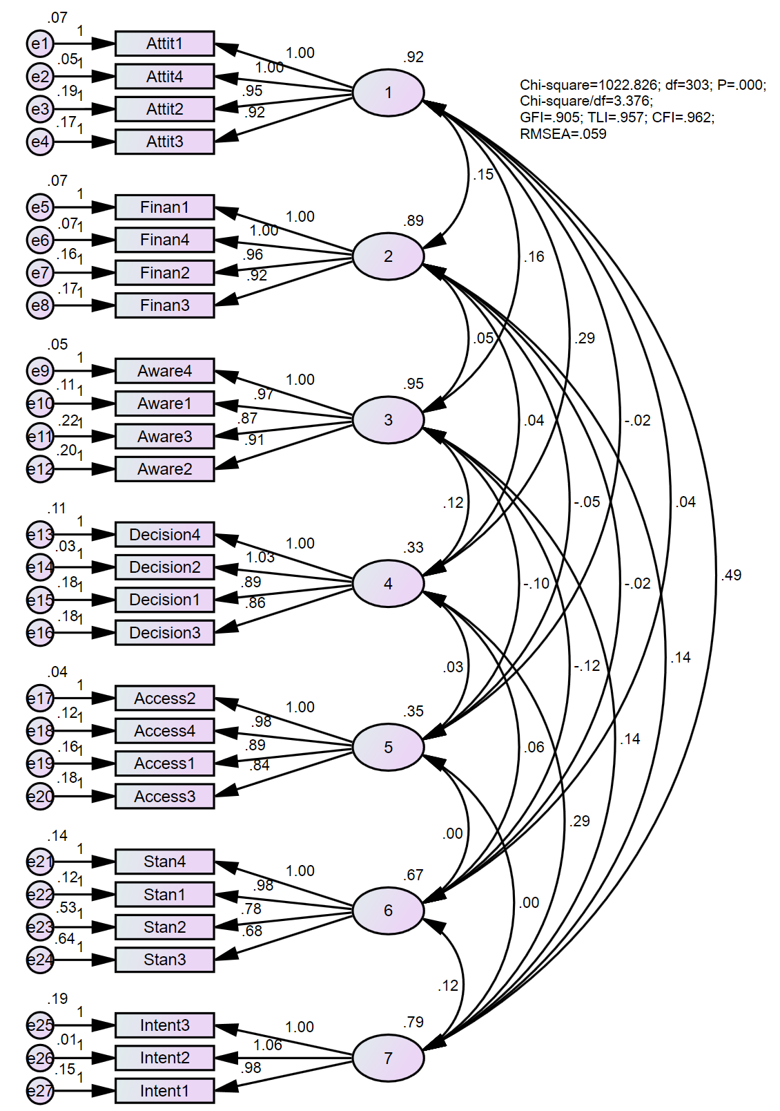

(Source: Data processed by SPSS 20.0 and Amos)

**Figure 2.** Testing CFA for factors affecting the intent and the decision to purchase life insurance products in Vietnam

**Table 2.** Testing coefficients for factors affecting the intent and the decision to purchase life insurance products in Vietnam

| Relationships | | | Unstandardized  Estimate | Standardized  Estimate | SE. | CR. | P | Hypothesis |
| --- | --- | --- | --- | --- | --- | --- | --- | --- |
| Intent | <--- | Attit | 0.537 | 0.558 | 0.033 | 16.079 | *** | Accepted |
| Intent | <--- | Finan | 0.080 | 0.084 | 0.030 | 2.657 | 0.008 | Accepted |
| Intent | <--- | Aware | 0.107 | 0.111 | 0.032 | 3.371 | *** | Accepted |
| Intent | <--- | Access | 0.175 | 0.084 | 0.057 | 3.074 | 0.002 | Accepted |
| Intent | <--- | Stan | 0.185 | 0.173 | 0.036 | 5.104 | *** | Accepted |
| Decision | <--- | Intent | 0.315 | 0.567 | 0.022 | 14.298 | *** | Accepted |

(Source: Data processed by SPSS 20.0, Amos)

Table 2 showed that five factors affected the intent and the decision to purchase life insurance products in Vietnam with a significance level of 0.01. These results are critical information for managerial implications to enhance the intent and the decision to buy life insurance products in Vietnam.

Results showed that the SEM assessment had factors affecting the intent and the decision to purchase life insurance products in Vietnam with a significance level of 0.01. Figure 3 showed that the assessment of the scale of the intent and the decision: CMIN/DF = 2.595 (<5.0), GFI = 0.927 (>0.8), TLI = 0.971 (>0.9) and CFI = 0.976 (> 0.9)

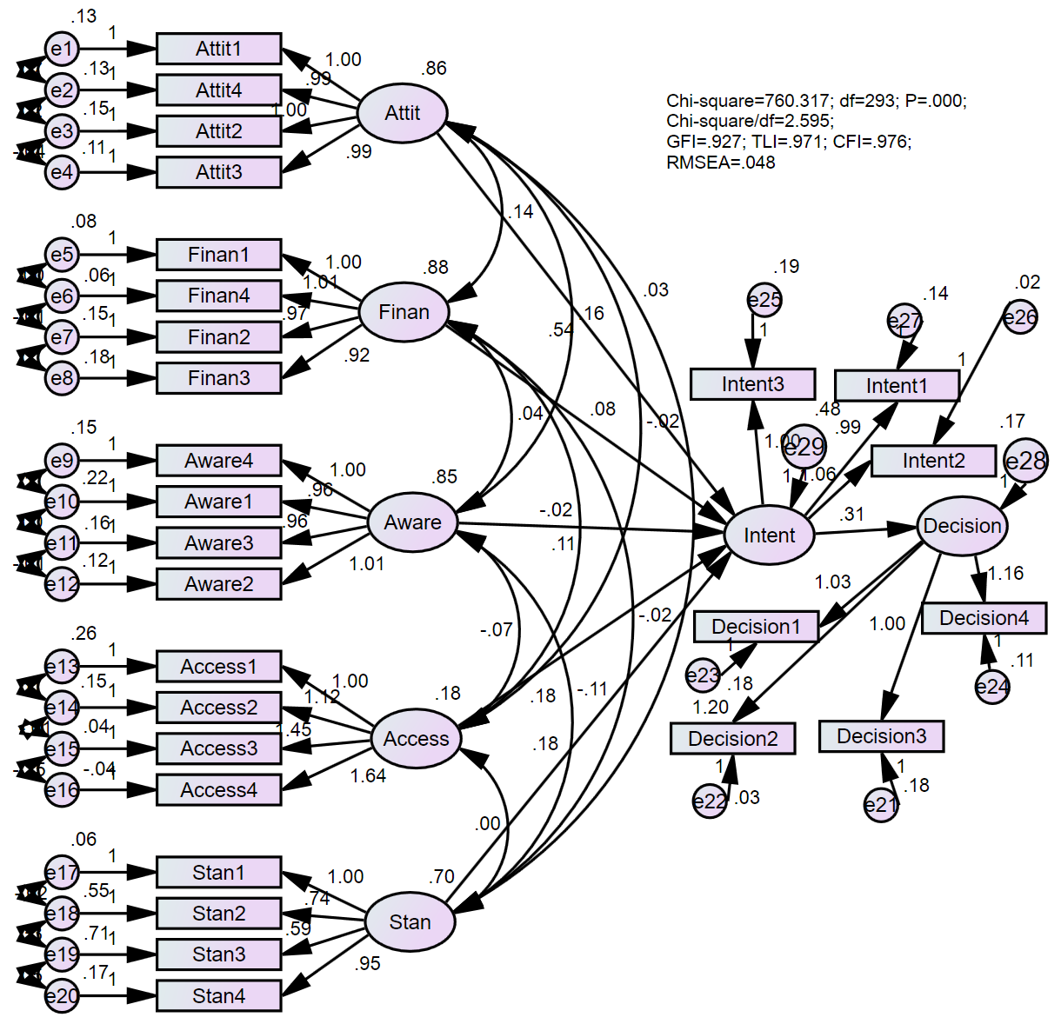

(Source: Data processed by SPSS 20.0, Amos)

**Figure 3.** Testing SEM for factors affecting the intent and the decision to purchase life insurance products in Vietnam

**Table 3.** Testing coefficients for factors affecting the intent and the decision to purchase life insurance products in Vietnam

| Parameter | | | SE | SE-SE | Mean | Bias | SE-Bias |
| --- | --- | --- | --- | --- | --- | --- | --- |
| Intent | <--- | Attit | 0.039 | 0.000 | 0.536 | -0.001 | 0.001 |
| Intent | <--- | Finan | 0.029 | 0.000 | 0.075 | -0.004 | 0.000 |
| Intent | <--- | Aware | 0.030 | 0.000 | 0.105 | -0.002 | 0.000 |
| Intent | <--- | Access | 0.055 | 0.001 | 0.166 | -0.009 | 0.001 |
| Intent | <--- | Stan | 0.038 | 0.000 | 0.180 | -0.004 | 0.001 |
| Decision | <--- | Intent | 0.028 | 0.000 | 0.315 | 0.000 | 0.000 |

(Source: Data processed by SPSS 20.0, Amos)

Table 3 showed that the bootstrap test results are very good with a sample of 10.000 customers. These results indicated that five factors affected the intent and the decision to purchase life insurance products in Vietnam with a significance level of 0.01. These results are essential information for managerial implications to improve the intent and the decision to purchase life insurance products in Vietnam.

**5. Conclusions**

The research results presented above have codified the effects of domestic and foreign research on decisions and intention to buy life insurance products comprehensively and critically. Besides, through research on the theoretical basis, the article has proposed a research model suitable to Vietnam’s current economic context.

The study has solved some problems based on surveying current and potential customers of insurance companies and in-depth interviews with industry experts. The research results are based on survey results from 700 customers related to the intent and the decision to purchase life insurance products in Vietnam. After evaluating the scale’s reliability through Cronbach’s Alpha coefficients and exploratory factor analysis (EFA), confirmation factor analysis (CFA), and SEM. The results showed that five factors positively affect the intent and the decision to purchase life insurance products in Vietnam with a significance level of 1%. Finally, some of the recommendations in each aspect that insurance companies applied managerial implications in Vietnam.

**6. Policy implications**

(1) The attitude towards life insurance products is also an essential factor in deciding whether to buy insurance from customers. Most customers do not have attitudes towards the outcome clearly in terms of age, procedures, fees, payment methods, benefits; It is not known that there is the addition of personal insurance and health insurance products. Besides, the long-life insurance period also makes customers feel confused when buying life insurance - similarly, Communication of life insurance guarantees to reduce concerns about the risk of being scammed. Since there are many forms of capital mobilization from people, high-interest rates/profits go bankrupt, reducing customer confidence. Thus, to change customer attitudes, it is necessary to focus on communicating the difference and superiority of purchasing life insurance compared to other forms of accumulation, especially with banks’ savings. Leaders organize life insurance training courses for insurance enterprises’ officers nationwide to best prepare for product distribution. The methods will provide students with the most general and basic knowledge about insurance and products to be deployed online. In particular, it is necessary to focus on training the part of sales skills for bank employees such as consulting skills, introducing and persuading customers.

(2) Customers are not fully aware of their responsibilities when they get old, showing that customers have not seen the risks that tend to increase in the future. Moreover, they believe that they are responsible for nurturing and creating a career for their children, so they spend most of their income on their children. Children have the responsibility to promote and take care of when they are sick. Because they are old and weak, they often do not keep a lot of money for themselves or hoard them in the form of bank deposits or buy gold or real estate - which can easily be converted into cash to spend. They know or do not think to purchase life insurance to have stable financial resources and ensure health care costs in old age, so it is necessary to raise awareness of the subjects about the responsibility for yourself when you get old. Therefore, there should be specific communication activities to help customers understand life insurance products. Therefore, insurance companies should develop profitability for this product to increase their attractiveness to risk-averse customers. Besides, the application of information technology also helps raise awareness and visualize life insurance services. This recommendation makes it easy for customers to look up information when needed, making it easy for the payment process of insurance policies and changing consumer attitudes towards this intangible and complex service type.

(3) To successfully exploit strange customers (cold market), first of all, it is necessary to understand the customers’ psychology when strangers (consultants) ask for insurance participation. At the same time, it is also essential to know that the current approach is not as practical as expected to change the way, increase efficiency, and reduce consequences. Due to the Vietnamese people’s limited awareness, the product’s information is confusing, mixed opinions about the industry. The approach also needs to change. Develop e-commerce applications that allow participants to be proactive and accessible in choosing insurance types for themselves, such as online deposits in applications of the Vietnam banking system. The development of an online life insurance system can simultaneously combine and utilize the foundation of electronic applications in the bank to integrate insurance benefits. This ideal not only can illustrate the details of the product in terms of both traditional insurance benefits and investment benefits, but it also can increase the tangibility of the product. It was helping customers to be more aware of life insurance products.

(4) Towards the goal of professionalizing and improving the quality of the team of insurance agents. Companies need to recruiting, training and taking exams to obtain digital certificates as prescribed by the Ministry of Finance and some life insurance companies. There are advanced training programs for a core team of insurance agents. But according to the author, it is necessary to upgrade the quality of the insurance agent right from the recruitment stage. In addition to strict recruitment regulations with reasonable penalties, it is time to set the minimum qualification to recruit an insurance agent is an intermediate or college degree. Financial management needs special attention because of the risk characteristics in insurance business activities and because of most insurance companies’ immaturity in the Vietnamese insurance market on the premises. In the general international market, developing new financial services is very complicated, such as investment-linked insurance, derivative instruments - the formation of economic groups - insurance with a more complex financial structure, and various other factors. Therefore, the insurance financial inspection and supervision agency needs to study the complete and advanced methods and systems of monitoring indicators to apply to businesses, thereby improving enterprises’ position in the international arena and contributing to building trust and brand with customers.

(5) One of the general solutions to restructure the insurance market is to improve information transparency. Specifically, it is required that insurance companies disclose sufficient, comprehensive, and corresponding information on time to help insurance buyers and related organizations understand their organizational structure and operations. Business, operating results, and financial situation of the enterprise are to promote market discipline. And at the same time, Companies help all concerned organizations and individuals understand insurance enterprises and types of risks and impact business performance and risk management. Companies plan an information system project to systematize synchronously and comprehensively all insurance industry data, both for management and supervision. Companies continue building a basis for calculating net insurance premiums and checking

This study has the following limitations: First, the study only surveyed some major city areas in Vietnam. The study’s generalization possibility will be higher if done in add many other cities in the country. Secondly, the new research has shown the independent variables, not exploiting the impact of control variables such as demographics. The study stopped analyzing at the descriptive statistics level for the demographic variables but did not further investigate regression or another testing. This study may be the research direction opened for future studies to overcome limitations and add additional factors affecting the customer’s decision to buy life insurance.

**References**

[1]. Ajzen I. and Gilbert M. (2006). Constructing a TPB questionnaire: Conceptual and methodological considerations. *Understanding attitudes and predicting social behavior*, 3(4) 148-172.

[2]. Albert O. F. (2014). Assessing the life insurance industry in Ghana. *European Journal of Business and Management*, 6(2), 11-22.

[3]. Ann W. T. and Lee H. C. (2011). Age, period, and cohort effects on life insurance purchases in the U.S. *Journal of Risk and Insurance*, 68(2), 33-39.

[4]. Baek E. D. and Sharon D. T. (2015). Human capital, bequest motives, risk, and the purchase of life insurance. *Journal of Personal Finance*, 4(2), 62-84.

[5]. Banderson Dan R. (2015). Determinants of Young Marrieds’ Life Insurance Purchasing Behavior: An Empirical Investigation. *Journal of Risk and Insurance*, 2(3), 37-45.

[6]. Beck T. V. and Ian W. H. (2012). Determinants of life insurance consumption across countries. *Journal* of *Economic Review*, 7(1), 51-62.

[7]. Bernard S. F. and Francois S. G. (2016). Asymmetric information in insurance: General testable implications. *Journal of Economics*, 7(4), 83-98.

[8]. Browne M. K. and Kihong K. A. (2013). An international analysis of life insurance demand. *Journal of Risk and Insurance*, 8(3), 16-34.

[9]. Eugene R. M. (2017). Determinants affecting the household life insurance of premium expenditures: An empirical investigation. *Journal of Risk and Insurance*, 7(5), 97-108.

[10]. Farni E. A. and Itzhak Z. B. (2016). Risk Aversion in the Theory of Life Insurance: The Fisherian Model. *Journal of Risk and Insurance*, 5(4), 6-16.

[11]. Finkelstein A. N. and Jonathan L. G. (2017). Beyond testing: Empirical models of insurance markets. *Applied Economics Letters*, 5(1), 11-36.

[12]. Gandolfi A. S. and Laurence M. J. (2016). Gender-based differences in life insurance ownership. *Journal of Risk and Insurance*, 5(12), 83-93.

[13]. Gary S. B. (2012). Market insurance, self-insurance, and self-protection. *Journal of Political Economy*, 8(5), 23- 48.

[14]. Gerry D. S. and Sajay K. E. (2018). The Relationship Between Property-Liability Insurance Premiums and Income: An International Analysis. *Journal of Risk and Insurance*. 5(2), 93-108.

[15]. Grable E. B. and Swarn C. F. (2013). Life insurance consumption as a function of wealth change. *Financial Services Review*, 2(4), 37-44.

[16]. Hair, J., Anderson, R., Tatham, R., & Black, W. (2010). *Multivariate data analysis with readings*. U.S: Prentice-Hall: Upper Saddle River, NJ, USA.

[17]. Harris S. B. (2016). Risk aversion and the propensities for self-insurance and self-protection. *Southern Economic Journal*, 7(3), 58-67.

[18]. Jean P. T. (2013). Adverse selection and moral hazard in insurance: Can dynamic data help to distinguish. *European Economic Association*, 1(2), 12-21.

[19]. Jeon B. C. and Soonnan K. R. (2017). Effect of private health insurance on health care utilization in a universal public insurance system: a case of South Korea. Journal of *Health Policy*, 13(1), 9-16.

[20]. Kasule S. G. (2018). Consumer attitudes, financial literacy and consumption of insurance in Kampala, Uganda. *Journal of Risk and Insurance*, 9(3), 19-34.

[21]. Mark C. H. (2014). Efficacy of the theory of planned behavior: A meta‐analytic review. *British Journal of Social Psychology*, 4(4), 71-99.

[22]. Nana O. F. (2017). Life Insurance in Nigeria: An Application of the Theory of Reasoned Action to Consumers’ Attitudes and Purchase Intention. *Service Industries Journal*, 7(7), 63-76.

[23]. Richard A. M. and Sharon T. C. (2018). The impact of rate regulation on claims: Evidence from Massachusetts automobile insurance. *Risk Management and Insurance Review*, 14(2), 73-99.

[24]. Sarni E. F. and Zilcha T. B. (2015). Uncertain lifetime, risk aversion, and life insurance. *Scandinavian Actuarial Journal*, 85(2), 9-23.

[25]. Sazio R. H. (2019). Acquisition and accumulation of life insurance in early married life. *Journal of Risk and Insurance*, 9(2), 13-34.

[26]. Tampbell R. A. (2018). The demand for life insurance: An application of the economics of uncertainty. *The Journal of Finance*, 35(5), 155-172.

[27]. Veaden R. S and Finley L. Y. (2018). Life insurance demand and household portfolio behavior. *Journal of Risk and Insurance*, 5(6), 85-98.

[28]. Wellian J. C. and Sendhil M. F. (2018). Health insurance coverage and take‐up: Lessons from behavioral economics. *The Milbank Quarterly*, 9(1), 17-34.

[29]. William J. T. (2017). Consumer choice: a study of insurance buying intention, attitudes and beliefs. *Service Industries Journal*, 4(2), 174-188.

[30]. Wuker J. M. (2018). Expenditures for life insurance among working-wife families. *Journal of Risk and Insurance*, 9(2), 25-33.

[31]. Zhu Y. H. (2017). One‐Period Model of Individual Consumption, Life Insurance, and Investment Decisions. *Journal of Risk and Insurance*, 7(3), 13-36.