An Integrated supply chain model
for educational management for higher education institute in Thailand
Artaphon Chansamut^{#1}
# Office of Dean ,Faculty of Home Economic Technology, Rajamangala University
of Technology Krungthep,Thailand
149 Charoen Krung Road Sathon Bangkok 10120

¹artaphon.c@mail.rmutk.ac.th

Abstract— The research aim is develop and to evaluate of an integrated supply chain model for educational management for higher education institute in Thailand. The sample group of 10 expert consisted of three experts on supply chain , two expert on curriculum, three expert on Educational Research and Evaluation and two expert on management, The expert selected by purposive sampling. All expert must have educational qualification at the doctoral degree level, and must have more than two years of work experience The statistical methods used in the research are arithmetic mean and standard deviation. The research findings show that integrated supply chain model for educational management for higher education institute in Thailand comprises six principal, namely, main components Suppliers, service provider,customer,finished product and consumer. The overall evaluation result an integrated supply chain model for educational management for higher education institute in Thailand shows the overall arithmetic mean of 3.60 and standard deviation of 0.64 .Suggesting that an integrated supply chain model for educational management for higher education institute in Thailand to be appropriately applied in actual work settings.

Keywords— An integrated supply chain ,E ducational management, Higher education institute in Thailand

1. Introduction
Nowadays, Education system have significant, the Thai government has realized the importance of adjusting the country to increase its capability to compete with other countries in every aspect. Especially the management of education, research, and the organization of university projects are important. Various University have increased their competitive ability by developing education, research and the organization of university projects to create quality products in agriculture and industry. One of their strategies is the application of an integrated supply chain management system.
Integrated supply chain allows agency to focus on assets that would allow the organization to reap more rewards,[1]The researcher has realized the importance of integrated supply chain development in order to cope with economic, social and political changes. In the business and industrial sector the changes have included the movement toward more and more application of the concept of integrated supply chain management system. This is because the business and industrial sector needs to be highly competitive due to increasingly high competitions from both within and outside the country. In order to be highly competitive, organizations in the sector need to have personnel with knowledge, ability and skills who can work efficiently to increase output and products. The organizations, therefore, need to have sufficient data and resources to increase their values and respond to the demand of their clients. Thus, an integrated supply chain management process is a key process to support the organization’s whole activities system from upstream to downstream. It enables the organization to promptly check the information system to ensure that the organization operates smoothly and effectively based on the determined strategies. [2].Based on this realization, the researcher has decided to develop an integrated supply chain model for educational management for higher education institute in Thailand for increase satisfaction of consumers.

2 Research Methodology
The research methodology is divided into 2 step which are:
1. Development of an integrated supply chain model for educational management for higher education institute in Thailand, being synthesis of element of an integrated supply chain model for educational management for higher education institute in Thailand which are suppliers, service provider, customer ,finished product and consumer.
2. Evaluating of an integrated supply chain model for educational management for higher education institute in Thailand, being present an integrated supply chain model for educational management for higher education institute in Thailand by ten experts and analyse the results of evaluation of
an integrated supply chain model for educational management for higher education institute in Thailand using means (X̅ )and standard deviation
(S.D.)following the weighing criteria of using five
rating scales of Likert.
3 Research Findings
3.1 Research findings about an integrated supply chain model for educational management for higher education institute in Thailand are presented in Figure 1, as shown below:

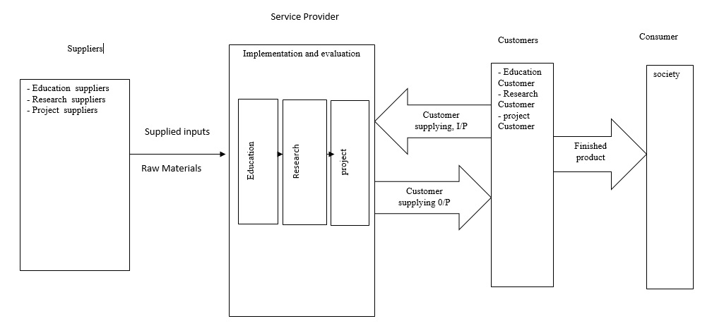
Figure 1: An integrated supply chain model for educational management for higher education institute in Thailand
3.2 Principles of an integrated supply chain model for educational management for higher education institute in Thailand
1 Suppliers
The suppliers are two major wings in suppliers for the universities - education suppliers ,research suppliers.as following
1.1 Education suppliers or Project suppliers :
1 Suppliers of the student (High School/College)
2 Suppliers of the faculty (Other Universities)
3 Self funding students
4 Source of Fund – Family (Parents, Siblings, Relatives, etc.)
5 Government and Private Organizations (Scholarship)
6 Suppliers of Assets or Equipment (Furniture, Computer, Networking Equipment, etc.)
7 Suppliers of Educational Materials (Stationery, Instruction Materials, etc.)
1.2 Research Suppliers:
1 Suppliers of Internal Research Projects (University Self Funding)
2 External Research Projects (External Research Funds, Ministry of Education, Private Organizations, etc.)
2 Service provider
A service provider mean university. There are two major factors including development and assessment for both education and research in the university. Through proper educational management, the university can produce quality outcomes for the society. The university have three decision levels for both education ,research and project in the university. Each level consists of two parts, namely development and assessment in
education and research including project. Development and assessment should be occurred concurrently for both education and research including project . Assessment at different levels assures stakeholders’ satisfaction in integrated supply chain.
3 Customers
The customer are two major wings in customers for
the universities: Education customers and research
customers ,as following
3.1 Education Customers:
1 Graduates with desirable quality
2 Family (Parents, Siblings, Relatives, etc.)
3 Employers of government and private organizations
3.2 Research Customers:
1 Funding organizations of research projects
2 Quality research outcomes (Researchers, Research Publications, Findings etc.)
3 Others (Research Professional Organizations - IEEE, INFORMS, ACM, Society of
Manufacturing Engineers etc. and Trade Associations - American Trade Association, Grocery Manufacturers Association etc.)
All customers of the universities are recognized as consuming output customers. Some of the graduates would be added in the service provider as the supplied input. On the other hand, some graduates would be acted as the supplied output to the end customer. Therefore, the result identified graduates with desirable quality as the supplying input customer in integrated educational supply chain management.
4 Finished product
Finished product are three major, as following
1 Graduated students with desirable characteristics including good virtues and morality, good knowledge and intellectual skills, good human relationship skills, good responsibility, good numerical analysis skill, good communication skill, and good information technology usage skills, etc.
2 Quality research outcomes may include problem solution, pure theory, thesis findings, internal and
external projects applications, researchers, research publications, or research findings, etc.
3 Quality project outcomes namely internal projects and external projects
5 Consumer
The consumers mean the end-of-process component of an integrated supply chain model .As universities are part of the society, the final
outcomes of supply chain, including graduates with desirable quality ,quality research outcomes and quality project outcomes are delivered to the society.[5],[6]
Table 1: Results of appropriateness evaluation of An integrated supply chain model for educational management for higher education institute in Thailand

ITems | $$\overline{X}$$ | S.D. | Suitability
Main components | 3.60 | 0.60 | High
Suppliers | 3.60 | 0.68 | High
Service provider | 3.63 | 0.50 | High
Customers | 3.60 | 0.63 | High
Finished product | 3.60 | 0.69 | High
Consumer | 3.60 | 0.70 | High
Total | 3.60 | 0.64 | High

From Table 1 shows that the experts agree that An integrated supply chain model for educational management for higher education institute in Thailand results as shown in table 1, the appropriateness of details in an integrated supply chain model for educational management for higher education institute in Thailand show the
appropriateness was at the high score. ($\overline{X}$= 3.60 ,
S.D =0.64)

4 Conclusion and Discussion
After the experts agree that, an integrated supply chain model for educational management for higher education institute in Thailand is considered to be high appropriate and the design was relevant to Chansamut has studied supply chain in higher education [3],[4] In addition, with the study of Habib recommended that integrated supply chain [5] and the results are in accordance to those of Habib and jangthirapanich who found that integrated supply chain as well.

5 Recommendations
An integrated supply chain model for educational management for higher education institute is high appropriate Therefore, if possible should be implemented in university for the model efficiently.

6. Acknowledgements
We greatly thank committee members, three experts on supply chain , two expert on curriculum, three expert on Educational Research and Evaluation and two expert on management within and outside the institution, who kindly provided supervision and advices as good models.
7. References
[1] Academy for International Modern
Studies.2021. integrated supply chain
management. Available at: https://aims
education/integrated-supply-chain-
management/
[2] Chansamut, A., Piriyasurawong., P.
Conceptual Framework of Supply Chain
Management Information System for
Curriculum Management Based on Thailand
Qualifications Framework for Higher
Education. International Journal of Managing
Value and Supply Chains (IJMVSC) . Vol 5
No 4 , 33-45. 2014
[3] Chansamut, A . The development of logistics
model for mange education for the universities.
Maejo information technology and innovation.
Vol 5 No 2 , 70-81. 2020.
[4 Chansamut, A . Supply chain model for
curriculum management base on Thailand
qualifications framework for higher
education. Maejo information technology
and innovation. Vol 5 No 2 , 70-81. 2020.
[5] Habib.M.2010. An empirical research of
ITESCM(integrated tertiary educational
supply chain management) model. Available
from: http://www.intechopen.com/ books/
management-and- services/an-empirical-
research-of-itescmintegrated-tertiary-
educational-supply-chain-management-model
[6] Habib.M., jangthirapanich. C 2009.A
Research Model of Integrated Educational
Supply Chain for the Universities. Available
from: https://www.academia.edu/303531/A
Research_Model_ of_Integrated_ Educational
_Supply_Chain_for_the.

